Leave management system components
- Frontend: Streamlit
- Backend: FastAPI
- Database: SQLite
Leave management system workflow
- 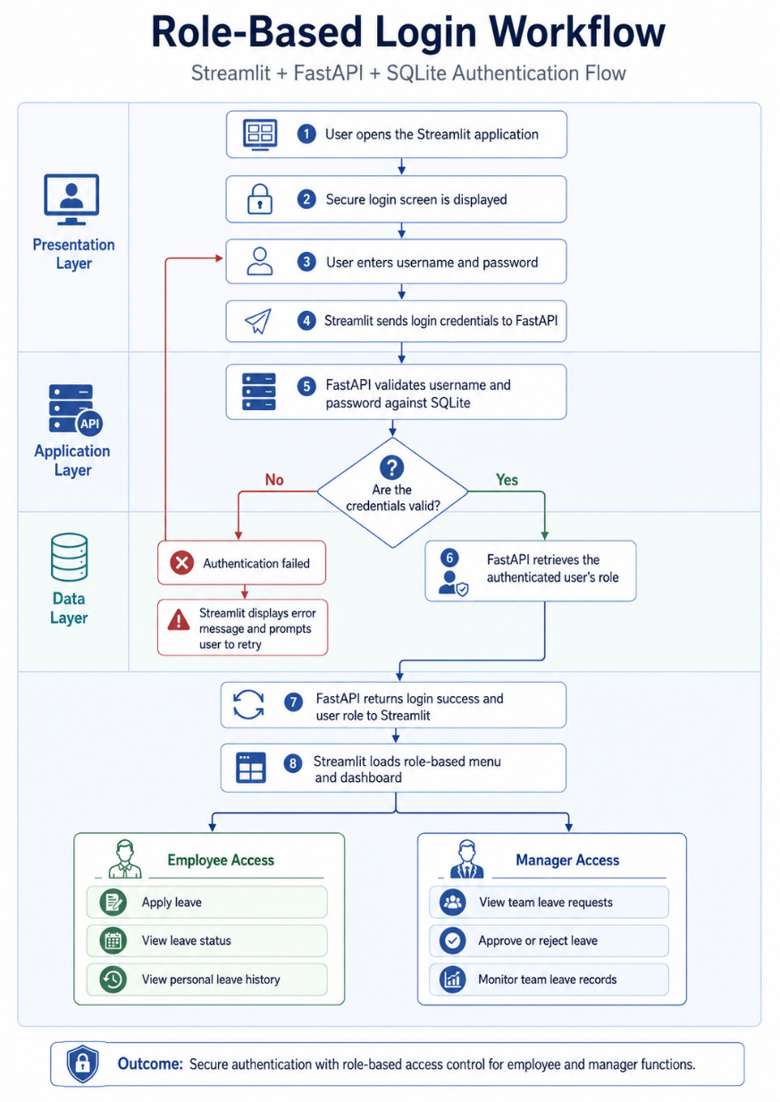
Code creation steps
- Mkdir leave_mgt_system
- Cd leave_mgt_system
- Venv\scripts\activate.bat
- Create a file frontend.py
- Create a file backend.py
- Write the necessary code in both files.

Install necessary libraries
- pip install fastapi uvicorn streamlit requests pandas

Code execution steps
- Run backend.py as python -m uvicorn backend:app --reload --port 8001
- Open a new terminal
- Run frontend.py as streamlit run frontend.py --server.port 8503
- http://127.0.0.1:8001
- http://127.0.0.1:8000/docs

http://127.0.0.1:8000/docs | http://127.0.0.1:8001/docs
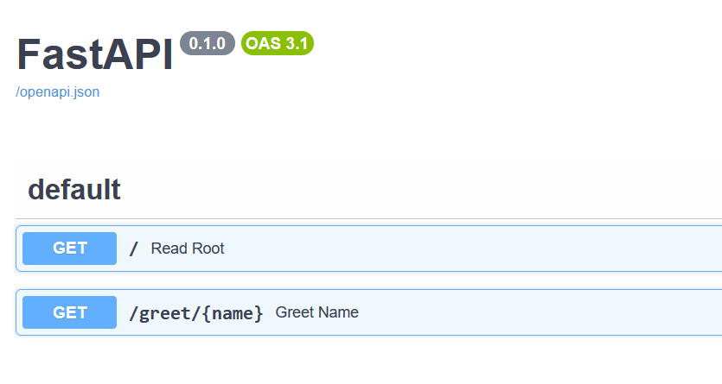 | 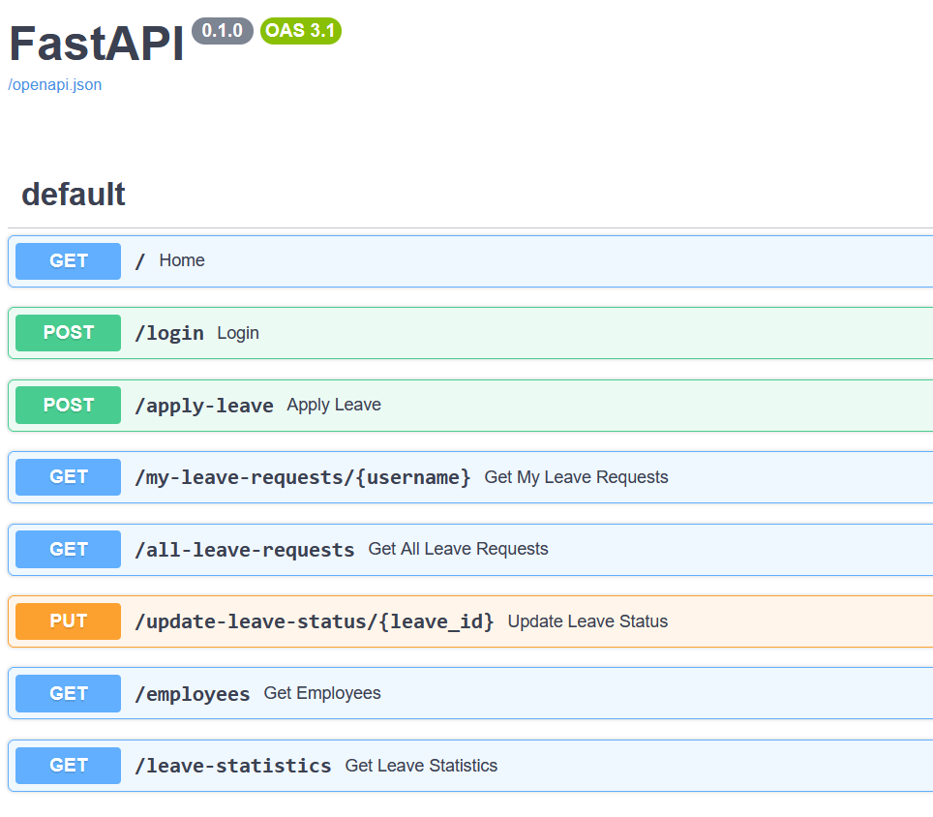

Login details
Use this exact login:
Username: arul
Password: 1234
For manager:
Username: manager
Password: admin123

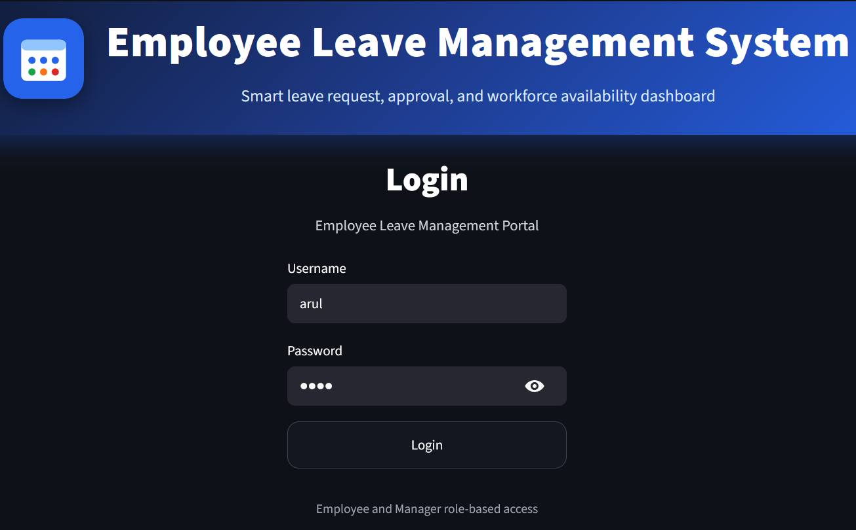
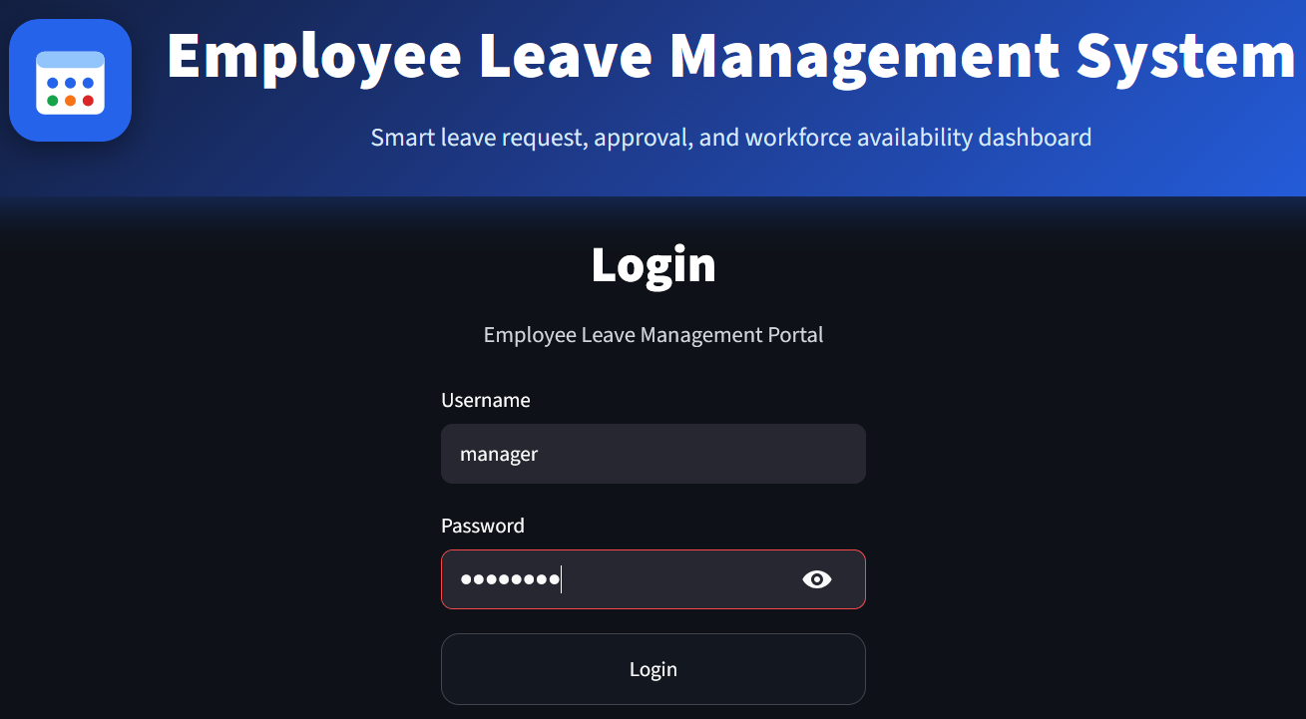

Leave statistics
